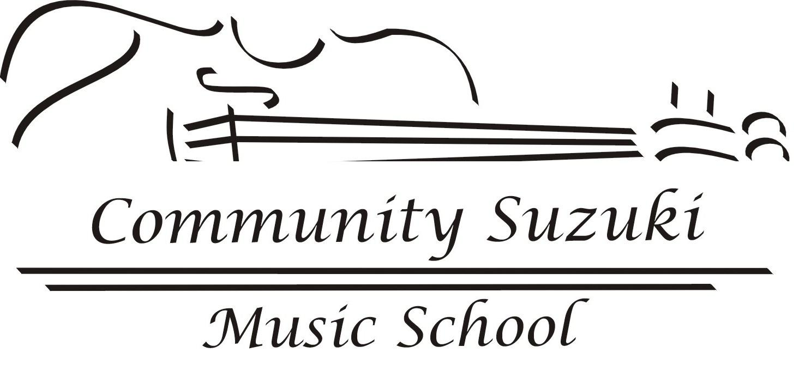

Registration Form

Student name:__________________________________________________

Parent Name:__________________________________________________

Address:______________________________________________________

City:_____________________________ State:_________ Zip:__________

Home phone:___________________ Cell phone: _____________________

E-mail:_______________________________________________________

Student age:_______________ Birthday:____________________________

Previous musical experience, if any:________________________________

Special needs or instructions, if any:________________________________

I have read, understood and agree to the policies of Community Suzuki Music School.

Name:__________________________________ Date:_________________

Policies and Procedures 2009-2010

Open Door Policy: Students and parents are welcomed and encouraged to observe other students' lessons and group classes.

Absence & Make-up Policy: There are no make-ups for student absences. Teacher absences will be made up at a time agreed upon by both student and teacher. If lesson cannot be made up, student will receive a refund at the end of the semester or will be credited the lesson during the summer session. Students may make arrangements with other students to switch lesson times if necessary.

Inclement Weather: Unless you are notified, there will be no lessons when the Chapel Hill-Carrboro City Schools and/or Chatham County Schools are closed for inclement weather. There will be open make-up lesson days scheduled at the end of the year for inclement weather cancellations. Alternatively, teachers may opt to make up lessons for inclement weather at a time mutually agreed upon by the teacher and individual students.

Tuition and Payments: Tuition covers a 34-week school year and may be paid yearly, per semester or on a monthly basis. Payments are due September 1st for one yearly payment, September 1st and January 1st for semester payments, and the 1st of each month for monthly payments. 30 minute lessons: $1192 per year, 45 minute lessons: $1788 per year, and 1 hour lessons: $2384 per year. Summer Session tuition will be based upon the number of lessons for which the student signs up.

Refunds: There are no tuition refunds after the first week of instruction of each month. Tuition will be refunded for any pre-paid period beyond one month.

Financial Aid: Community Suzuki Music School provides aid to students with a demonstrated need through the Community Suzuki Financial Aid Program. The amount of aid is based on household income, family size, and financial obligations, and is limited by the availability of Community Suzuki Music School resources. Copies of the form will be available through your instructor. Financial aid is considered annually on a case-by-case basis.

Registration Fee: A registration fee is charged once to each new family with children enrolled in private lessons. The fee is $50. This fee is nonrefundable and is due at the same time the first tuition payment is made.

Group Performances: Children who regularly attend group lessons are invited to participate in group performances. Community Suzuki Music School schedules multiple community performances each year. Performers should wear white shirts and black pants or skirts (at least knee length) and black shoes and socks or stockings. For casual or outdoor concerts, denim shorts, pants or skirts will be acceptable.

Recitals: We hold at least one formal solo recital per school year. Recitals are a great motivator for the children and are a chance for us to celebrate every student's accomplishments. Please try to attend even when your children are not performing.

Practice: Parents assume full responsibility for the consistency and quality of practice and listening sessions and will use their best efforts to ensure success. Students are expected to practice a minimum average of 5 days per week.

Other Suzuki Opportunities: Being a Suzuki student is to be part of a worldwide educational movement. Students will have the opportunity to participate in local, state, national, and international workshops and institutes. Please take advantage of these unique experiences.

Required Materials: Violin, Bow and Case; Suzuki Bk. 1 and Suzuki Bk. 1 CD, notebook, shoulder rest, cleaning cloth, white shirt for group performances.

Non-discrimination Policy: Community Suzuki Music School does not discriminate on the basis of race, color, age, sex, religion, sexual orientation, physical or developmental disability, or national origin.

